A Project Report on

**Hospital Mangement System**

By Chukka Sanjeet (2382182)  
Intern (INTAIA25TAL001)

**Table of Contents:**

1. Introduction 2

2. About the Project 2

a) Purpose 2

b) Scope 2

i. Requirements Capture 2

ii. Data Integration 2

iii. Information Management 2

3. System Requirements 2

a) Architecture Diagram 2

b) Schema Mapping 2

c) Table Definition 2

4. Staging Layer 2

5. Star Schema 2

6. Functional Requirements 2

a) Patient Module 2

b) Insurance Module 3

c) Physician Module 4

d) Appointment Module 5

e) Billing Module 6

7. Project Overview 7

a) Key Features: 7

8. Conclusion 7

**List of Tables:**

Table 1: Target Table Description

Table 2: Table Definition

Table 3: Patient Requirement Description

Table 4: Insurance Requirement Description

Table 5: Physician Requirement Description

Table 6: Appointment Requirement Description

Table 7: Billing Requirement Description

**List of Figures:**

Fig. 1: Architecture Diagram

Fig. 2: Schema Mapping

Fig. 3: Staging Layer

Fig. 4: Star Schema

Fig. 5: Patient Requirement Mapping

Fig. 6: Insurance Requirement Mapping

Fig. 7: Physician Requirement Mapping

Fig. 8: Appointment Requirement Mapping

Fig. 9: Billing Requirement Mapping

# **Introduction**

This project is based on the Talend ETL tool to achieve the client's requirements. ETL (Extract, Transform, Load) is a crucial process in the world of data integration, enabling us to extract data from various sources, transform it into a consistent and meaningful format, and load it into a destination system for analysis and reporting. In this project, we aim to showcase the significance of Talend as a powerful ETL tool, facilitating seamless data movement, efficient data manipulation, and ultimately empowering data-driven decision-making.

# **About the Project**

## **Purpose**

The purpose of the project “Hospital Management System” is to develop a robust system that efficiently manages information related to various patient, physician, appointment, insurance, and billing details. This system aims to streamline data integration processes, ensuring accurate and timely reporting and analysis. By leveraging Talend as the ETL tool, the project seeks to enhance data extraction, transformation, and loading capabilities to meet business requirements effectively.

## **Scope**

The scope of this project includes the following:

### Requirements Capture

Systematically document functional requirements.

### Data Integration

Utilize Talend for ETL processes to extract, transform, and load data into the target data warehouse. Ensure data consistency and integrity across all modules.

### Information Management

Develop functionalities to manage information on patients, physicians, appointments, insurance, and billing. Ensure accurate and timely reporting based on the managed data.

Implement data warehousing concepts to support historical data analysis and reporting.

# **System Requirements**

## **Architecture Diagram**

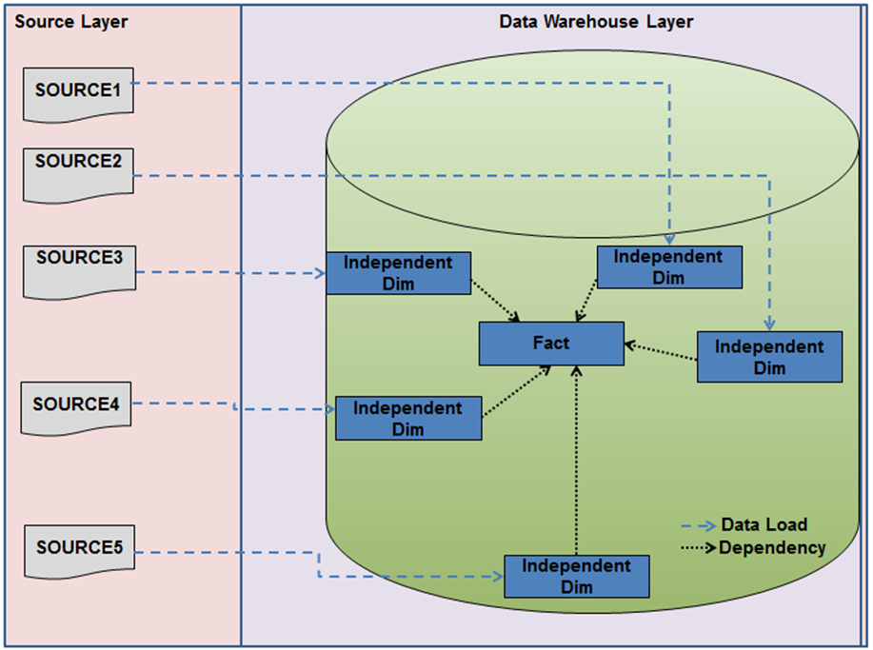

Fig. 1: Architecture Diagram

## **Schema Mapping**



Fig. 2: Schema Mapping

## **Table Definition**

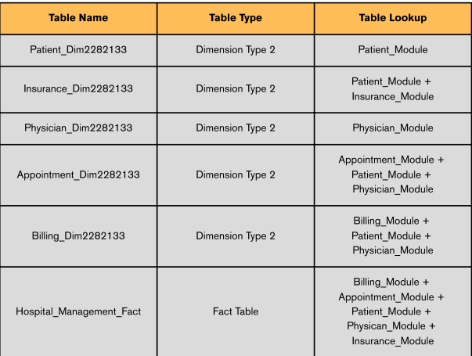

Table 2: Table Definition

# **Staging Layer**

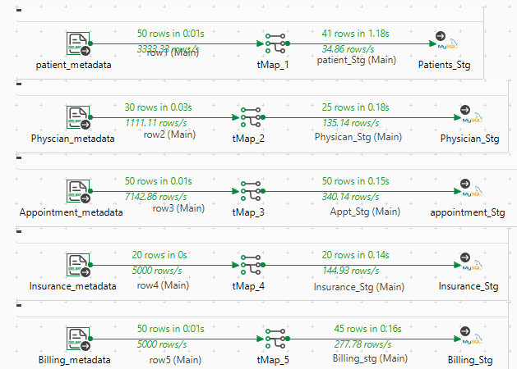

Fig. 3: Staging

# **Star Schema**

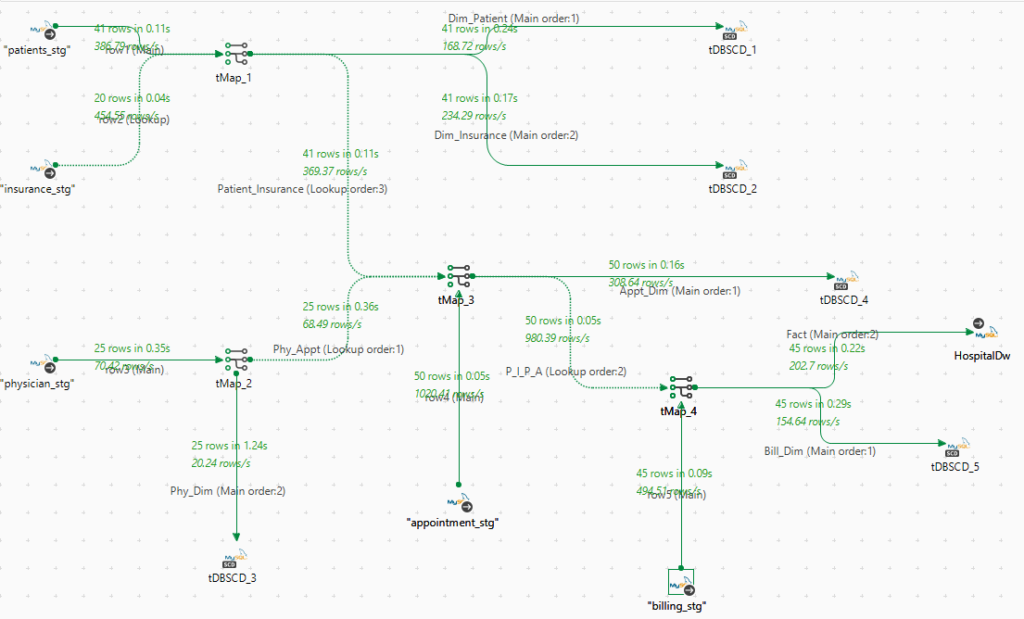

Fig. 4: Star Schema

# **Functional Requirements**

## **Patient Module**

|  |
| --- |
| Requirements |
| Produce report on patient details who are not from USA, not covered by any insurance |
| Produce report on patient details above age 50 |
| Dimension Patient is used to get the Patient Details of the ABC Hospital including insurance details |

Table 3: Patient Requirement Description

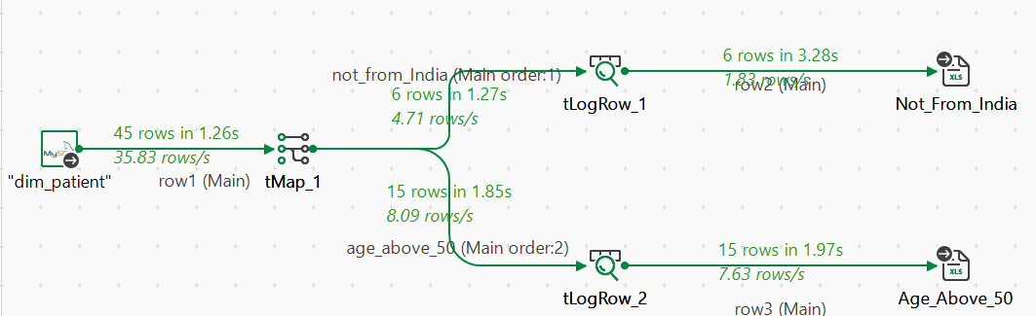Fig. 5: Patients Requirement Mapping

## **Insurance Module**

|  |
| --- |
| Requirements |
| To store patient info who have insurance amount greater than 200000 |
| To store and fetch count of patients covered by each insurance |
| Dimension Insurance is used to get the Patient Insurance details |

Table 4: Insurance Requirement Description

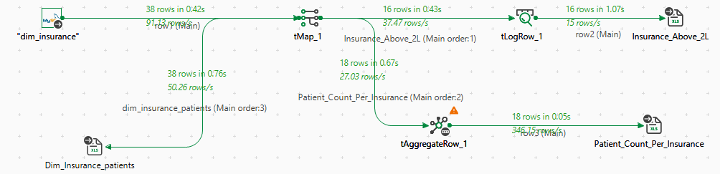

Fig. 6: Insurance Requirement Mapping

## **Physician Module**

|  |
| --- |
| Requirements |
| Report of physician details who are surgeon who joined hospital between 2000 to 2010 |
| To display physician details based on  i) Name  ii) Experience |
| To verify whether the physicians are head of the department |
| Dimension credit is used to get the Physician information |

Table 5: Physician Requirement Description

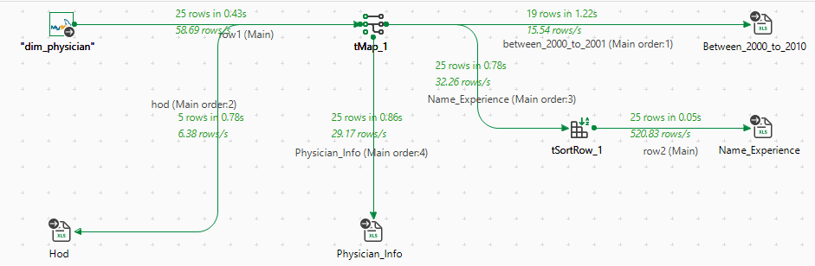

Fig. 7: Physician Requirement Mapping

## **Appointment Module**

|  |
| --- |
| Requirements |
| To store patient info who have appointment today |
| To fetch Patient details based on physician and examination room |
| To display patient who have appointment booked in future and covered by insurance |
| Dimension Appointment is used to get the Appointment details |

Table 6: Appointment Requirement Description

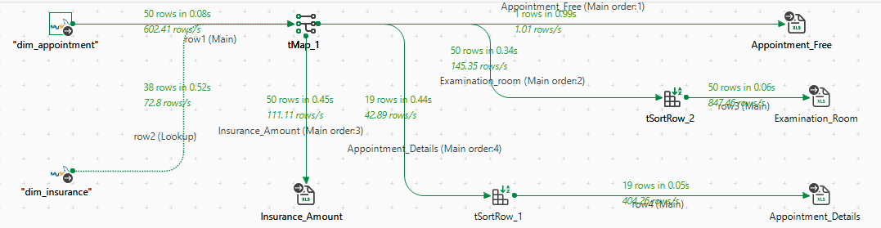

Fig. 8: Appointment Requirement Mapping

## **Billing Module**

|  |
| --- |
| Requirements |
| To store the patient details who don’t have insurance coverage and need to pay the complete amount |
| To fetch the patient and the actual amount to be paid (Amount to be paid – Covered by insurance) |
| To fetch physician who had maximum amount to be paid |
| To fetch the list of patients who needs to pay this month |
| Dimension Billing is to report the Billing details of the patients |

Table 7: Billing Requirement Description

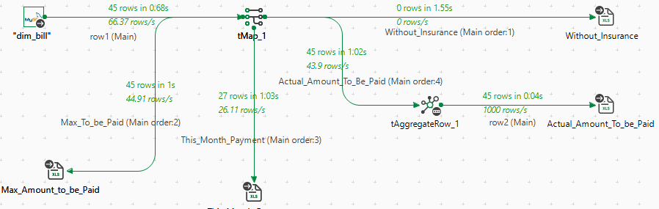

Fig. 9: Billing Requirement Mapping

# **Project Overview**

The Hospital Management System Data Warehouse for ABC Hospital is designed to enhance data integration and management for patient, physician, appointment, insurance, and billing analysis. This project utilizes Talend as an ETL (Extract, Transform, Load) tool to streamline data processing and improve decision-making.

## **Key Features:**

* **Patient Module**
* Manage Patient Details: Efficiently handle patient information, including personal details, medical history, and contact information.
* Generate Reports: Produce reports on patient demographics, medical history, and treatment outcomes.
* **Physician Module**
* Manage Physician Details: Track physician qualifications, specialties, and contact information.
* Generate Reports: Produce reports on physician performance, patient feedback, and appointment schedules.
* **Appointment Module**
* Manage Appointments: Schedule, reschedule, and cancel patient appointments.
* Generate Reports: Produce reports on appointment trends, patient wait times, and physician availability.
* **Insurance Module**
* Manage Insurance Details: Handle insurance policy information and coverage details.
* Generate Reports: Produce reports on insurance claims, coverage statistics, and patient eligibility.
* **Billing Module**
* Manage Billing Details: Track invoices, payments, and financial records.
* Generate Reports: Produce reports on billing trends, payment statuses, and financial performance.

1. **Technical Implementation:**

* **ETL Process:** Extracts data from multiple sources, transforms it according to business logic, and loads it into a structured data warehouse.
* **Database Management:**  Store and process patient, physician, appointment, insurance, and billing data. Ensure data consistency and accuracy across all modules.
* **Reporting & Insights:** Produces customized reports to enhance hospital management and decision-making.

This streamlined approach should help in effectively managing the data and generating valuable insights for ABC Hospital.

# **Conclusion**

In conclusion, the Hospital Management System Data Warehouse for ABC Hospital effectively integrates patient, physician, appointment, insurance, and billing data to enhance business decision-making. By leveraging Talend as an ETL tool, the system ensures efficient data extraction, transformation, and loading, enabling accurate and timely reporting and analysis across all modules.